

**ICICI AZURE ENVIRONMENT   
DESIGN DOCUMENT**

  
**Document Revision History:**



|  |  |  |  |  |  |
| --- | --- | --- | --- | --- | --- |
| **Version No.** | **Authored/Modified By** | **Reviewed By** | **Approved**  **By** | **Last modified  Date** | **Modifications Done** |
| **1.0** | Pallavi Singh |  |  | 01/09/2023 | Created |
|  |  |  |  |  |  |
|  |  |  |  |  |  |
|  |  |  |  |  |  |
|  |  |  |  |  |  |
|  |  |  |  |  |  |

|  |  |  |  |
| --- | --- | --- | --- |
| **Name** | **Role** | **Contact details** | **Signature Date** |
| Pallavi Singh | Cloud Architect | [Pallavi2.singh@lntinfotech.com](mailto:ImranH.Khan@lntinfotech.com) | 01/09/2023 |
|  |  |  |  |
|  |  |  |  |
|  |  |  |  |
|  |  |  |  |
|  |  |  |  |
|  |  |  |  |

**Table of Contents**

1 Introduction 5

2 Document Purpose 5

3 Document Scope 5

4 Scope of Work 5

4.1 In-Scope 5

4.2 Out of-Scope 6

5 Target Audience 6

6 Landscape Details 7

7 Validation Methodology 9

8 Low Level Design Architecture 10

9 Azure environment considerations 12

10 Subscription Layout 13

10.1 Region 13

10.2 Architectural Decision Summary 14

10.3 Networking 14

10.3.1 APP Vnet 14

10.3.2 DB Vnet 15

10.3.3 Route Tables 15

10.3.4 Network Security Groups 15

10.4 Firewall URLs and Ports Details 17

11 Azure Storage 17

11.1 Disk Types 17

11.2 Disk Model 18

12 Azure Compute 20

12.1 Virtual Machines 20

13 Platform-as-a-Service Components 22

13.1 Azure Container Registry 22

13.2 App Services 23

13.2.1 Logic App 23

13.2.2 Function App 23

13.3 API Management Service 23

13.4 Azure Kubernetes Service 23

13.5 Azure ML Workspace 24

13.6 ADF (Azure data factory) 24

13.7 ADLS (Storage accounts) 24

13.8 Azure data bricks 26

13.9 Azure EventHub 27

13.10 Azure Purview 27

13.11 Cosmos DB 27

13.12 Azure SQL DB (PrivateEye) 28

13.13 Dedicated SQL Pools 28

13.14 Cognitive Services 28

13.15 Synapse Service for Private Eye 29

14 Acronyms 29

# Introduction

This document details the Infrastructure Design for ICICI Bank Cloud Data Platform Development environment planned on Microsoft Azure designed by LTI. This document accomplishes the business requirements of Agile/Scalable infrastructure to build Net New deployment on Azure and migrate the identified workloads to Cloud.

# Document Purpose

The purpose of this document is to define the Azure Infrastructure Layout for ICICI (CDP) Infrastructure and applications. It refers to design considerations, design decisions, recommendations, and constraints that ICICI should be aware of and sign-off on the architecture before moving on to the implementation phase.

This document will assist the following teams: -

* Build Team - The LTI team will use this document as the basis for the solution implementation.
* Data Team – To understand what infrastructure is deployed to be managed and transfer data to the cloud
* Application Team – To understand the underlying infrastructure on Cloud to support & develop the application.

# Document Scope

This document covers the detailed design for Azure Services covering Azure Networking & Security, Storage, Compute, High Availability, Disaster Recovery, Governance & Monitoring.

# Scope of Work

The scope of work is to is to help provision the Azure cloud infrastructure for the data platform. This includes working in conjunction with the ICICI cloud team to deploy the native and non-native components of data platform infrastructure in T&D environment.

## In-Scope

* Creating and finalizing the network architecture diagram
* Providing SRS document for Dev, UAT, Prod and DR environments
* Provisioning and resources configuration
* Validation of the infrastructure platform
* Hyper care

## Out of-Scope

* Servers and Applications planned for decommission is excluded for migration
* Apps running on workstation or client OS is excluded for migration
* Datacenter consolidation and hardware decommissioning
* Application re-engineering or rearchitecting which includes code level changes

# Target Audience

This document is intended for a technical audience, including the following:

|  |  |
| --- | --- |
| Name | Title |
| Manoj Joshi | ICICI Chief Manager |
| Sanjay Kumar | ICICI Tech Lead |
| Girish Nookella | ICICI Manager |
| Pallavi Singh | LTI Security Architect |
| Hrishikesh Katvi | LTI Infra Architect |
|  |  |

# Landscape Details

* **191 components and services** are planned to be deployed in Azure cloud

|  |  |  |  |
| --- | --- | --- | --- |
| **Services** | **Location** | **Environment** | **Grand Total** |
| Linux vm’s | Central India | PROD | 4 |
| Windows Vm’s | Central India | PROD | 6 |
| App services | Central India | PROD | 3 |
| Storage accounts | Central India | PROD | 10 |
| ADF | Central India | PROD | 1 |
| Databricks | Central India | PROD | 1 |
| API Management | Central India | PROD | 1 |
| ML workspace | Central India | PROD | 1 |
| Event hub namespace | Central India | PROD | 1 |
| Purview | Central India | PROD | 1 |
| AKS | Central India | PROD | 1 |
| Cosmos DB | Central India | PROD | 1 |
| SQL DB | Central India | PROD | 2 |
| SQL Server | Central India | PROD | 3 |
| SQL Pools | Central India | PROD | 2 |
| Container Registry | Central India | PROD | 1 |
| Cognitive Services | Central India | PROD | 2 |
| Synapse Services | Central India | PROD | 1 |
| Apache spark pool | Central India | PROD | 1 |
| App service plan | Central India | PROD | 1 |
| Application insight | Central India | PROD | 1 |
| Computer vision | Central India | PROD | 1 |
| Custom vision | Central India | PROD | 2 |
| Disk | Central India | PROD | 22 |
| Disk encryption set | Central India | PROD | 1 |
| Event grid system | Central India | PROD | 1 |
| Function App | Central India | PROD | 1 |
| Key vault | Central India | PROD | 1 |
| Log analytics workspace | Central India | PROD | 1 |
| Manage identity | Central India | PROD | 3 |
| NAT Gateway | Central India | PROD | 1 |
| NSG | Central India | PROD | 13 |
| Private DNS zone | Central India | PROD | 2 |
| Private Endpoint | Central India | PROD | 37 |
| Public IP | Central India | PROD | 3 |
| Network Interfaces (NIC) | Central India | PROD | 47 |
| Route table | Central India | PROD | 12 |
| Shared Dashboard | Central India | PROD | 1 |
| Snapshot | Central India | PROD | 1 |
| Solutions | Central India | PROD | 1 |
| **Grand Total** |  |  | **212** |

# Validation Methodology

We have defined a validation methodology to define and decide on the components in the target environment. The decision was made following the below factors

**Workshop:**

Internal workshop was conducted with each tower to understand the existing landscape and what would be required in the Target infrastructure.

**Q & A Session:**

Discussions were conducted with the Application and Infra stakeholders to derive at the final number of inventory & landscape components required for the target infrastructure.

**Testing**

Performing network connectivity test between components in different Virtual Networks and On-Prem connectivity.

# Low Level Design Architecture

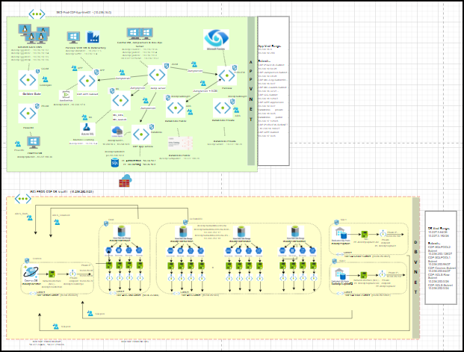



**Summary:** The above diagrams show the Low-Level Design for ICICI CDP PROD Azure environment. It includes Azure IAAS/PAAS components, Network layout, Connectivity, and other components at a broader level.

Below is the summarized list of components considered in the target architecture:

|  |  |  |
| --- | --- | --- |
| Components | Details | Decision |
| Subscription | PROD Region | Central India |
| Network | Virtual Network Model | Hub & Spoke |
| Network | Connectivity to On-Premises | ExpressRoute |
| Network | Connectivity from End Users | VDI |
| Network | Connectivity between VNet | VNet Peering |
| Storage | Disk | Managed Disk |
| Container Registry | Container Registry | Azure Container Registry |
| Container Orchestration | Kubernetes service | Azure Kubernetes Service |
| SQL | SQL Server | Azure SQL Database Server |
| SQL | SQL Database | Azure SQL Database |

# Azure environment considerations

Microsoft Azure is dynamically growing every day with new features and enhancement of existing features. AZURE Services considered in this document may enhance, integrate, or retire in future as per Microsoft release. Cost and Availability of Azure features are subject to Azure region.

LTI has followed Microsoft Cloud Adoption Framework to follow the Microsoft Best Practices for designing Azure Subscriptions, Virtual Network, and other Azure components. Document updated with design Considerations updated as per CAF.

Below consideration are taken care based on the assessment and our understanding with the stakeholders.

* **Capacity planning** — One of the biggest challenges during a Cloud migration is misunderstanding the differences between applications hosted on Cloud and traditional local deployments. Capacity planning and resource management are different on Azure and must be understood when developing in the Cloud. We have considered right size for the applications based on the assessment and we can scale up or scale down based on the requirement on the cloud.

|  |  |
| --- | --- |
| **\*** | * + Rightsized VM to be selected based on Assessment report & Application requirement on Cloud |

* **Bandwidth** — Provisioning enough local bandwidth is critical, especially if we are planning for a hybrid cloud solution. Based on the migration requirement we have factored Express Route with 1 Gbps tunnel for Data Migration & the bandwidth can be scaled up to 10Gbps during the production stage.

|  |  |
| --- | --- |
| **\*** | * + 1Gbps S2S VPN connectivity during migration phase   + Bandwidth to be revalidated based on the requirement during the steady state |

* **Downtime** — Downtime during a migration is unavoidable. We have discussed the downtime window, time & impact with the stakeholders to have a planned approach. Migration of different applications is strategically spread across, so we have minimal business impact.

|  |  |
| --- | --- |
| **\*** | * + Communication will be sent to the required stakeholders during the migration |

* **Application Compatibility** — We must ensure that the applications are compatible before migrating to Cloud. During assessment and interviews with the application owners we have analyzed that the OS and Application are compatible to move to Cloud.

|  |  |
| --- | --- |
| **\*** | * + Assessment report and interviews with the Application team will help with the final report |

# Subscription Layout

Azure Subscription, the doorway to the Azure environment for deploying resources and Azure services. It covers the requirements of different LOBs, such as setting up differentiated levels of access and authorization along with a unique subscriber ID, billing location and a set of available resources.

**IBank_CDP_Production** subscription will act as a single subscription providing Services for CDP PROD Environment.

|  |  |
| --- | --- |
| Components | Details |
| Subscription Name | IBank_CDP_Production |
| Subscription ID | 611376f5-bfd1-48aa-86e5-29bdab0f6094 |
| Plan | Enterprise Agreement |
| Billing | Monthly |
| Coverage Term | Active until cancelled |
| Reserved Instance | Yes |

**Recommendations**

* Assign a minimum number of users as Subscription Owners.
* Use Azure Resource Management RBAC whenever possible to control the amount of access that administrators have, and log what changes are made to the environment

|  |  |
| --- | --- |
| **\*** | **Design Decision**   * + Single Subscription – IBank_CDP_Production   + Region – Central India for PROD |

## Region

Primary region is **Central India** and Secondary region is **South India** is considered for the target infrastructure. As per best practices Azure Paired Region is considered for DR Site.

|  |  |
| --- | --- |
| Components | Region |
| Location | Central India |
| Availability Zone | Yes |
| Service Availability | All |
| Data residency | India |

## Architectural Decision Summary

Several Architectural Decisions have been made while writing this document. These decisions can be found in individual components entitled Design Decisions.” However, a summary of these decisions is provided below: -

|  |  |  |
| --- | --- | --- |
| Decision Summary | | |
| Sr. No. | **Title** | **Reasoning and Description** |
| 1 | Azure Subscription | Single Subscription – IBank_CDP_Production |
| 2 | Hub-Spoke Technology | Hub Virtual Network to be act as a central point of connectivity to on premise and Internet. Spoke virtual network to be used to isolate workloads. |
| 3 | Network Security Group | Dedicated NSG individual Subnets / VMs to control Port and IP based communication |
| 4 | VNET-to-VNET | To support connectivity between Spoke & Hub infrastructure |

## Networking

Based on our understanding of the environment and as per best practices, we will go with **2 VNET** (Virtual Network). This was considered to isolate the shared services applications. We will have separate Subnets for each environment as per Microsoft’s recommendations and best practises.

To ensure cloud-based applications are visible to the corporate network we have Express Route connection. Existing bandwidth is **1Gbps** for migration considering **130+ TB** of data to be migrated from On-Prem Datacentres to Cloud and to accommodate connectivity for business and operations.



### APP Vnet

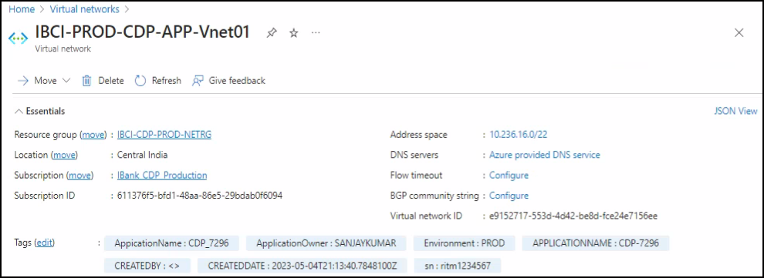

### DB Vnet

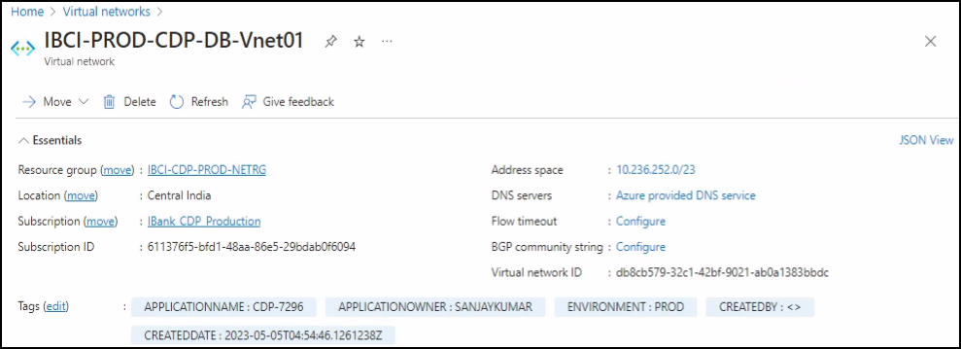

### Route Tables

|  |  |  |  |
| --- | --- | --- | --- |
| **NAME** | **RESOURCE GROUP** | **LOCATION** | **SUBSCRIPTION** |
| IBCI-CDP-PROD-ADB-RT | ibci-cdp-prod-netrg | Central India | IBank_CDP_Production |
| IBCI-CDP-PROD-ADLS_Cleansed-RT | ibci-cdp-prod-netrg | Central India | IBank_CDP_Production |
| IBCI-CDP-PROD-ADLS_RAW-RT | ibci-cdp-prod-netrg | Central India | IBank_CDP_Production |
| IBCI-CDP-PROD-APP-RT | ibci-cdp-prod-netrg | Central India | IBank_CDP_Production |
| IBCI-CDP-PROD-AppSubnet-RT | ibci-cdp-prod-netrg | Central India | IBank_CDP_Production |
| IBCI-CDP-PROD-COSMOSDB-RT | ibci-cdp-prod-netrg | Central India | IBank_CDP_Production |
| IBCI-CDP-PROD-Goldengate-RT | ibci-cdp-prod-netrg | Central India | IBank_CDP_Production |
| IBCI-CDP-PROD-Jumpserver-RT | ibci-cdp-prod-netrg | Central India | IBank_CDP_Production |
| IBCI-CDP-PROD-ML-RT | ibci-cdp-prod-netrg | Central India | IBank_CDP_Production |
| IBCI-CDP-PROD-PowerBI-RT | ibci-cdp-prod-netrg | Central India | IBank_CDP_Production |
| IBCI-CDP-PROD-Purview-RT | ibci-cdp-prod-netrg | Central India | IBank_CDP_Production |
| IBCI-CDP-PROD-SQLpool-RT | ibci-cdp-prod-netrg | Central India | IBank_CDP_Production |

### Network Security Groups

Azure network security groups can be used to filter network traffic to and from Azure resources in an Azure virtual network. A network security group contains security rules that allow or deny inbound network traffic to, or outbound network traffic from, several types express of Azure resources. For each rule, we can specify source and destination, port, and protocol.

Azure network security groups can be associated to a subnet or to a network interface of a VM. To avoid unexpected communication problems, it is recommended to attach NSG to a subnet, or a network interface, but not both.

NSG rule consists of the following components:

* Name – A unique name which should be easy for administrators to use to find the rule.
* Priority – This is an integer between 100 and 4096, which should be unique. This value defines the processing order of the rule, with rules containing lower values (higher priority) being executed first.
* Source or destination – This field indicates which application or user(s) the rule is applicable for. This can be an IP Address, IP Address range or Azure resource.
* Protocol – The TCP, UDP or ICMP protocol which will be analyzed.
* Direction – This indicates whether the traffic is inbound or outbound.
* Port Range – This will specify which port or range of ports the rule is applicable for.
* Action – Setting either Allow (the traffic through) or Deny (and block the traffic) will specify the action to be taken by the NSG when network traffic matching the rule is identified.

|  |  |
| --- | --- |
| **\*** | **Design Decision**   * NSG’s will be associated to Azure Subnet * Azure Virtual Network Endpoint feature will be leveraged to restrict the access to Azure Public Services only from Virtual Network/VNA. |

|  |  |  |  |
| --- | --- | --- | --- |
| **NAME** | **RESOURCE GROUP** | **LOCATION** | **SUBSCRIPTION** |
| databricksnsgxyjci52f2jcqs | ibci-cdp-prod-apprg01 | Central India | IBank_CDP_Production |
| IBCI-CDP-PROD-APP-NSG | ibci-cdp-prod-netrg | Central India | IBank_CDP_Production |
| IBCI-CDP-PROD-CLEANSED-NSG | ibci-cdp-prod-dbrg01 | Central India | IBank_CDP_Production |
| IBCI-CDP-PROD-Cosmos-NSG | ibci-cdp-prod-dbrg01 | Central India | IBank_CDP_Production |
| IBCI-CDP-PROD-DATABRICK-NSG | ibci-cdp-prod-apprg01 | Central India | IBank_CDP_Production |
| IBCI-CDP-PROD-GGVM-NSG | ibci-cdp-prod-apprg01 | Central India | IBank_CDP_Production |
| IBCI-CDP-PROD-JSVM-NSG | ibci-cdp-prod-apprg01 | Central India | IBank_CDP_Production |
| IBCI-CDP-PROD-ML-NSG | ibci-cdp-prod-apprg01 | Central India | IBank_CDP_Production |
| IBCI-CDP-PROD-PBIVM-NSG | ibci-cdp-prod-apprg01 | Central India | IBank_CDP_Production |
| IBCI-CDP-PROD-PURVIEW-NSG | ibci-cdp-prod-apprg01 | Central India | IBank_CDP_Production |
| IBCI-CDP-PROD-RAW-NSG | ibci-cdp-prod-dbrg01 | Central India | IBank_CDP_Production |
| IBCI-CDP-PROD-SQL1-NSG | ibci-cdp-prod-dbrg01 | Central India | IBank_CDP_Production |
| IBCI-CDP-PROD-SQL2-NSG | ibci-cdp-prod-dbrg01 | Central India | IBank_CDP_Production |

## Firewall URLs and Ports Details

Below are the attached sheets for Firewall opening ports for Production:



# Azure Storage

Azure Storage is the cloud storage solution for modern applications that rely on durability, availability, and scalability. Azure Storage is massively scalable, so you can store and process hundreds of terabytes of data to support the big data scenarios required by scientific, financial analysis, and media applications

* **Standard Storage** performance tier which allows you to store Tables, Queues, Files, Blobs and Azure virtual machine disks. This tier is hosted on Hard Disk Drives (HDD)
* **Premium Storage** performance tier which currently only supports Azure virtual machine disks. This tier is hosted on Solid State Drives (SSD).
* **Archive Storage:** It is optimized for storing data that is rarely accessed and stored for at least 180 days with flexible latency requirements (on the order of hours).

## Disk Types

A Microsoft Azure virtual machine is created from an image or a disk. All virtual machines use one operating system disk, a temporary local disk, and they enable the use of multiple data disks depending on the selected size of the virtual machine. All images and disks, except the temporary local disk, are created from virtual hard disk (VHD) files that are stored as page blobs in a storage account in Microsoft Azure.

Following are the different type of disks attached to VMs:

* **Operating system disks:** The default operating system disk that is used in the virtual machine. This disk is durable, but it has Write-behind disk caching enabled.
* **Data disks:** Additional durable disks that have Write-behind disk caching disabled
* **Temporary disks:** The contents are wiped away during reboot. This disk is intended for paging files, so that paging files don’t count against the storage quota.

|  |  |
| --- | --- |
| **\*** | **Design Decision**   * Data Disk will be a combination SSD and Premium SSD as per Application/Server requirements |

## Disk Model

There are two type of Disk model available Managed Disk and Un Managed Disk

**Managed Disk -** Azure Managed Disks simplifies disk management for Azure IaaS VMs by managing the storage accounts associated with the VM disks.

* No Storage Account Management overhead
* Disk snapshots
* Predictable performance with no throttling
* Integration with Availability Sets
* Disk level RBAC permission
* No Custom Size
* Pay for complete disk size

**Un-Managed Disk -** Unmanaged disks are the traditional type of disks that have been used by VMs, and additionally we should manage storage accounts associated with disks.

* Pay what you use
* LRS, GRS supported.

Listed below is the disk comparison available in Azure & what is recommended for Hoist.

|  |  |  |  |  |
| --- | --- | --- | --- | --- |
| Feature | Ultra Disk | Premium SSD | Standard SSD | Standard HDD |
| Disk type | SSD | SSD | SSD | HDD |
| Scenario | IO-intensive workloads | Production and performance sensitive workloads | Web servers, lightly used enterprise applications and dev/test | Backup, non-critical, infrequent access |
| Example | Transaction heavy SQL, Oracle DB | DB Servers | Prod App / DB Servers | Dev / Test Workloads |
| Max throughput | 2,000 MB/s | 900 MB/s | 750 MB/s | 500 MB/s |
| Max IOPS | 160,000 | 20,000 | 6,000 | 2,000 |

|  |  |  |  |
| --- | --- | --- | --- |
| Disk Name | Disk Type | Size (GB) | Owner |
| IBCICDP4JS01_OsDisk_1_ffacaef6d87e4089ad926e626237e182 | Standard SSD LRS | 64 | IBCICDP4JS01 |
| IBCICDP4SFTP01_DataDisk_0 | Premium SSD LRS | 127 | IBCICDP4SFTP01 |
| IBCICDP4SFTP01_OsDisk_1_cc8a7b89e33a440c9c3f222c61760038 | Premium SSD LRS | 127 | IBCICDP4SFTP01 |
| IBCICDP4WMS01_OsDisk_1_d98f5c92ba124a93bed76060d0d59c05 | Premium SSD LRS | 228 | IBCICDP4WMS01 |
| IBCICDP4WPB01_OsDisk_1_a71d8e71507a42ef992068e84f5aa608 | Standard SSD LRS | 128 | IBCICDP4WPB01 |
| IBCICDPVM402-osdisk | Standard SSD LRS | 30 | IBCICDPVM402 |
| IBCICDPVM403-osdisk | Standard SSD LRS | 30 | IBCICDPVM403 |
| ibcicdpvm403_datadisk | Standard SSD LRS | 200 | IBCICDPVM403 |
| IBCICDPVM405_OsDisk_1_13eb9174a2c4462e963c43e76380747b | Standard SSD LRS | 127 | IBCICDPVM405 |

|  |  |
| --- | --- |
| **\*** | **Design Decision**   * All the disk used will be Managed Disk |

# Azure Compute

Azure provides Virtual Machine types based on storage, memory, Network, graphics, and CPU capacity.

Below table defines the different type of VM along with the purpose relevant to Hoist environment

|  |  |  |  |
| --- | --- | --- | --- |
| Series | Purpose | Use Case | Environment |
| D Series | General purpose | Enterprise grade application & relational DB | PROD |

|  |  |  |  |  |  |
| --- | --- | --- | --- | --- | --- |
| Name | Subscription | Size | Disk | Location | Private IP |
| IBCICDP4JS01 | Linux | Standard_D2s_v3 | 1 | Central India | 10.227.225.22 |
| IBCICDP4SFTP01 | Windows | Standard_D2as_v4 | 2 | Central India | 10.227.224.164 |
| IBCICDP4WMS01 | Windows | Standard_D4s_v3 | 1 | Central India | 10.227.225.26 |
| IBCICDP4WPB01 | Windows | Standard_D4s_v3 | 1 | Central India | 10.227.225.21 |
| IBCICDPVM402 | Linux | Standard_D4s_v3 | 1 | Central India |  |
| IBCICDPVM403 | Linux | Standard_D4s_v3 | 2 | Central India |  |
| IBCICDPVM405 | Windows | Standard_D4s_v3 | 1 | Central India | 10.227.225.27 |

## Virtual Machines

|  |  |  |  |  |  |
| --- | --- | --- | --- | --- | --- |
| **NAME** | **RESOURCE GROUP** | **LOCATION** | **OPERATING SYSTEM** | **SIZE** | **DISKS** |
| 019660418da5463297cceadf262fe10a | databricks-rg-ibcicdp1adb01-rur5iy2urkbi4 | Central India | Linux | Standard_DS5_v2 | 3 |
| 0adc594098ad4654a4cc0ba9ac9dca51 | databricks-rg-ibcicdp1adb01-rur5iy2urkbi4 | Central India | Linux | Standard_DS4_v2 | 3 |
| 1c4bf19d8ed04fd8b3e2e4e5531002cb | databricks-rg-ibcicdp1adb01-rur5iy2urkbi4 | Central India | Linux | Standard_DS5_v2 | 3 |
| 2a70285cd52b41d0ad3dedfc9ee80e23 | databricks-rg-ibcicdp1adb01-rur5iy2urkbi4 | Central India | Linux | Standard_DS5_v2 | 3 |
| 77f15edcc6644ab9b4464b5ab1bdb708 | databricks-rg-ibcicdp1adb01-rur5iy2urkbi4 | Central India | Linux | Standard_DS3_v2 | 3 |
| 9216f597f6004ab285785c259f8d64ac | databricks-rg-ibcicdp1adb01-rur5iy2urkbi4 | Central India | Linux | Standard_DS5_v2 | 3 |
| aabc8853e7824d638c54debcf32e101e | databricks-rg-ibcicdp1adb01-rur5iy2urkbi4 | Central India | Linux | Standard_DS4_v2 | 3 |
| bc054e7b6d764ff68e91e69c58532adf | databricks-rg-ibcicdp1adb01-rur5iy2urkbi4 | Central India | Linux | Standard_DS5_v2 | 3 |
| d7817c3093744f508d0942343bd7a33e | databricks-rg-ibcicdp1adb01-rur5iy2urkbi4 | Central India | Linux | Standard_DS4_v2 | 3 |
| ibcicdp1csvm1 | ibci-cdp-prod-apprg01 | Central India | Windows | Standard_D4s_v3 | 2 |
| ibcicdp1dpsvm1 | ibci-cdp-prod-apprg01 | Central India | Windows | Standard_D4s_v3 | 1 |
| ibcicdp1pbivm01 | ibci-cdp-prod-apprg01 | Central India | Windows | Standard_D4s_v3 | 1 |
| ibcicdp1shirvm1 | ibci-cdp-prod-apprg01 | Central India | Windows | Standard_D4s_v3 | 1 |
| ibcicdp1vmgg01 | ibci-cdp-prod-apprg01 | Central India | Linux | Standard_DS14_v2 | 3 |
| ibcicdp1vmgg02 | ibci-cdp-prod-apprg01 | Central India | Linux | Standard_DS14_v2 | 3 |
| ibcicdp1vmgg03 | ibci-cdp-prod-apprg01 | Central India | Linux | Standard_DS14_v2 | 3 |
| ibcicdp1vmgg04 | ibci-cdp-prod-apprg01 | Central India | Linux | Standard_DS14_v2 | 3 |
| ibcicdp1vmjs01 | ibci-cdp-prod-apprg01 | Central India | Windows | Standard_D8s_v3 | 1 |
| ibcicdp1vmjs02 | ibci-cdp-prod-apprg01 | Central India | Windows | Standard_D8s_v3 | 1 |

# Platform-as-a-Service Components

## Azure Container Registry

**Azure Container Registry** is utilized to build, store, and manage container images and artifacts in a private registry for all types of deployments in AKS cluster. Azure container registries will be used for container development and deployment pipelines. AKS cluster pull container Images from the container registry deployed for web apps, APIs with private endpoint enabled to securely connected by AKS over private network.

Below are the configurations used in the Azure container registry:

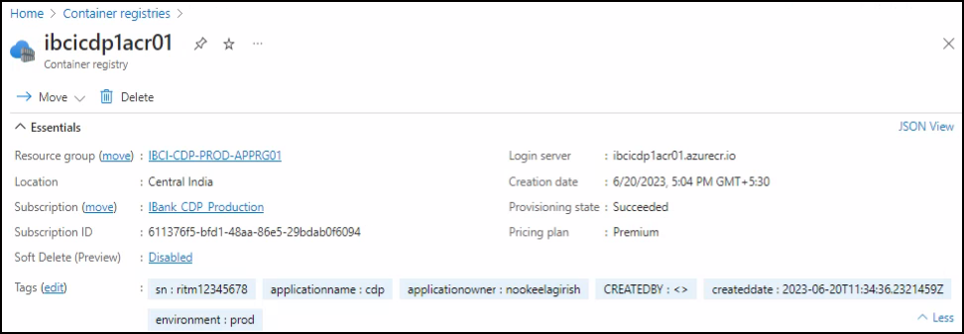

Managed Identity:

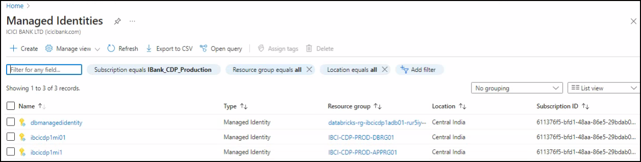

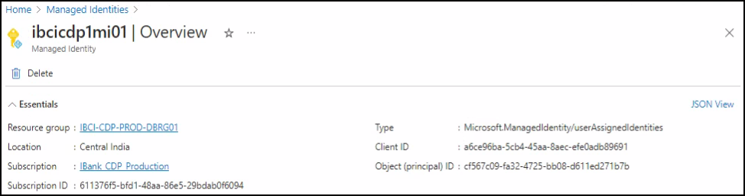

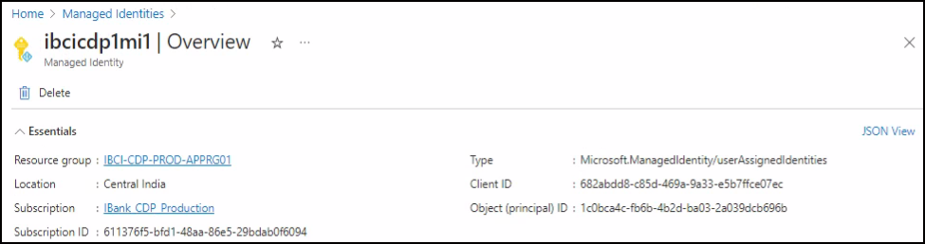

## App Services

App Service Web Apps lets you quickly build, deploy, and scale enterprise-grade web, mobile, and API apps running on any platform. Meet rigorous performance, scalability, security and compliance requirements while using a fully managed platform to perform infrastructure maintenance.

### Logic App

Yet To Deploy

### Function App

Yet To Deploy

## API Management Service

To publish APIs to external, partner, and internal developers to unlock the potential of their data and services Azure API management services is considered. API Management provides the core competencies to ensure a successful API program through developer engagement, business insights, analytics, security, and protection of any backend and launch a full-fledged API program based on it.

Below configuration were used for API management service for all subscriptions

Yet To Deploy

## Azure Kubernetes Service

Azure Storage is the cloud storage solution for modern applications that rely on durability, availability, and scalability. Azure Storage is massively scalable, so you can store and process hundreds of terabytes of data to support the big data scenarios required by scientific, financial analysis, and media applications

* **Standard Storage** performance tier which allows you to store Tables, Queues, Files, Blobs and Azure virtual machine disks. This tier is hosted on Hard Disk Drives (HDD)
* **Premium Storage** performance tier which currently only supports Azure virtual machine disks. This tier is hosted on Solid State Drives (SSD).

Yet To Deploy

## Azure ML Workspace

Every workspace must be assigned to an Azure subscription, which is where billing happens. You use resource groups like folders to organize and manage resources, including the workspace you're about to create.

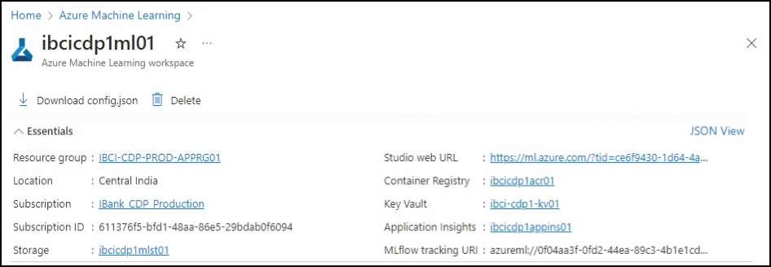

## ADF (Azure data factory)

Azure Data Factory allows you to configure a Git repository with either Azure DevOps or GitHub. Git is a version control system that allows for easier change tracking and collaboration. Choose whether to connect your self-hosted integration runtime to Azure Data Factory via public endpoint or private endpoint. This applies to self-hosted integration runtime running either on premises or inside customer managed Azure virtual network.

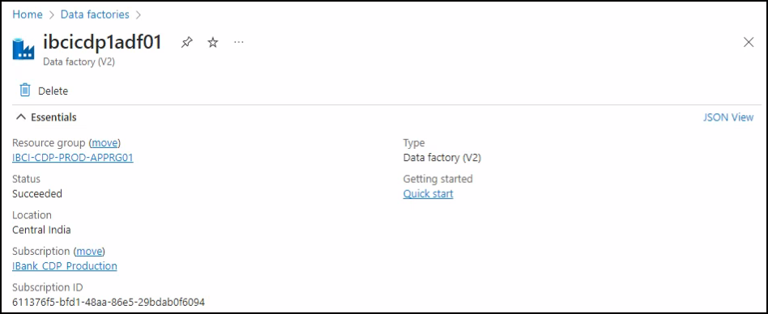

## ADLS (Storage accounts)

Azure Storage is a Microsoft-managed service providing cloud storage that is highly available, secure, durable, scalable, and redundant. Azure Storage includes Azure Blobs (objects), Azure Data Lake Storage Gen2, Azure Files, Azure Queues, and Azure Tables. The cost of your storage account depends on the usage and the options you choose below.

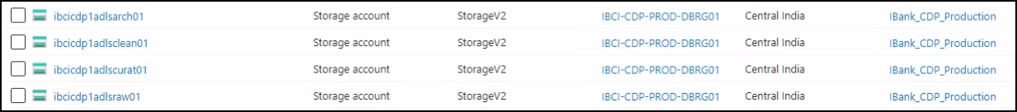

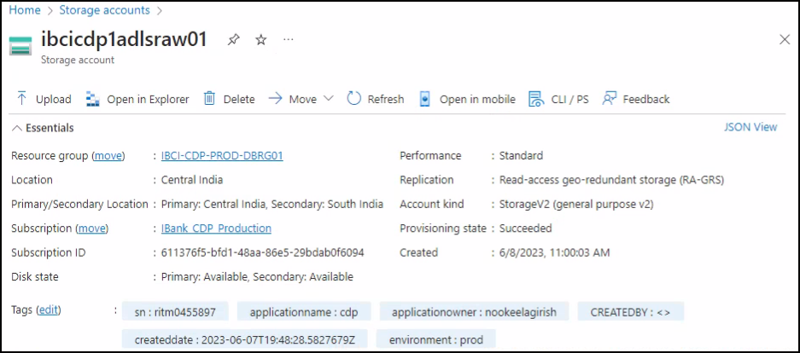

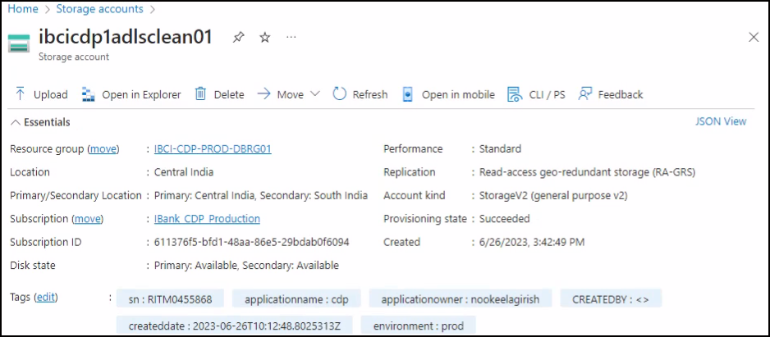

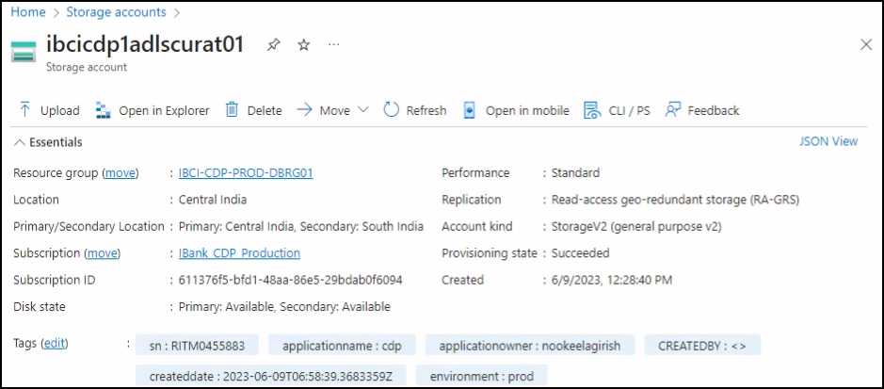

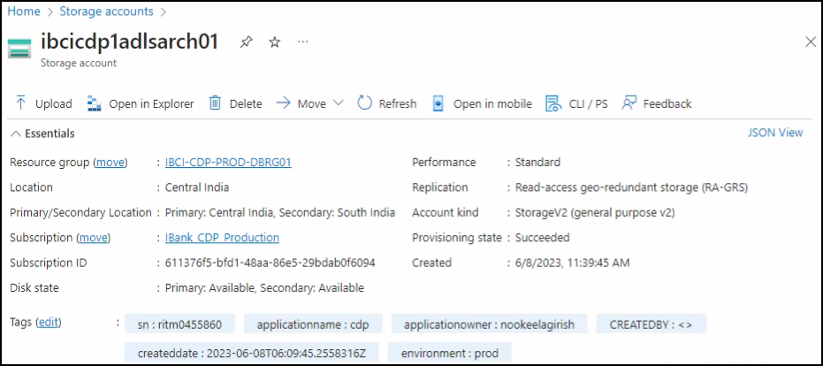

## Azure data bricks

Select the subscription to manage deployed resources and costs. Use resource groups like folders to organize and manage all your resources.

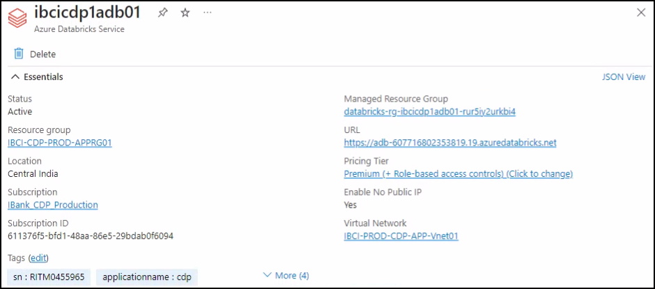

Managed Identity:

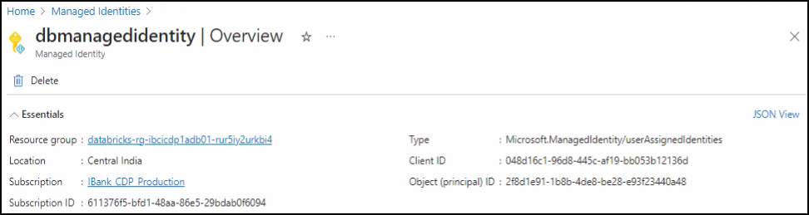

## Azure EventHub

Select the subscription to manage deployed resources and costs. Use resource groups like folders to organize and manage all your resources. You can connect to this namespace either publicly, via public IP addresses or service endpoints, or privately, using a private endpoint.

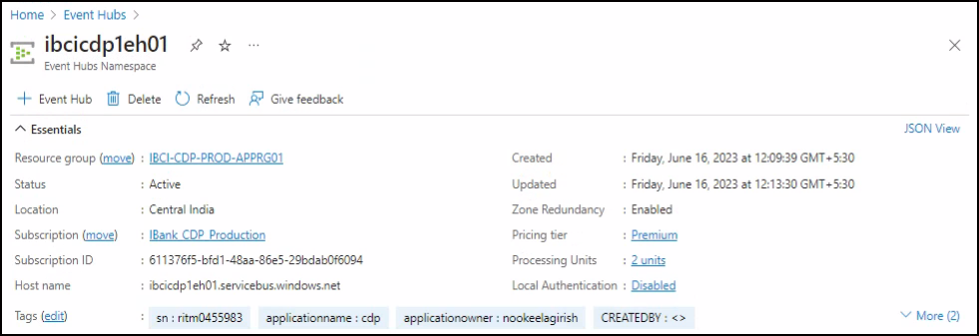

## Azure Purview

Create a Microsoft Purview account to develop a data governance solution in just a few clicks. A storage account and EventHub will be created in a managed resource group in your subscription for catalogue ingestion scenarios. You can connect to your Microsoft Purview account either publicly, via public IP addresses or service endpoints, or privately, using a private endpoint.

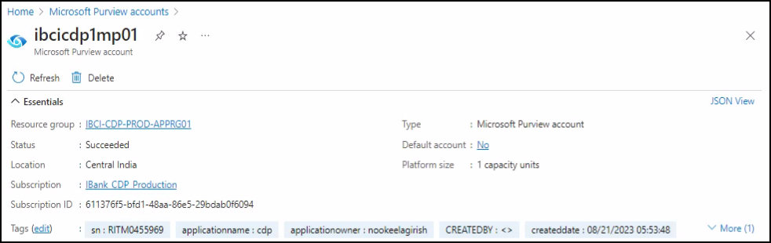

## Cosmos DB

Azure Cosmos DB is a fully managed NoSQL database service for building scalable, high-performance applications

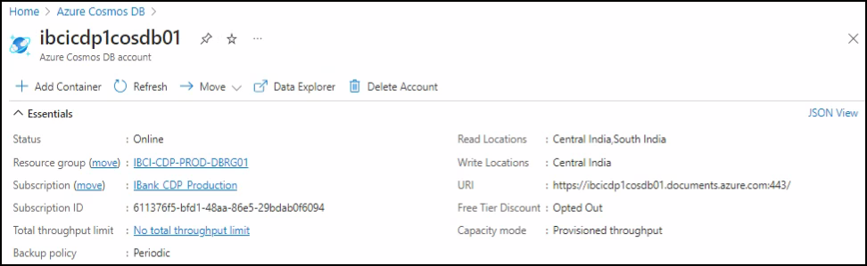

## Azure SQL DB (PrivateEye)

SQL database server is a logical container for managing databases and elastic pools. Complete the Basic tab, then go to Review + Create to provision with smart defaults or visit each tab to customize.

Yet To Deploy

## Dedicated SQL Pools

Create a SQL database with your preferred configurations. Complete the Basics tab then go to Review + Create to provision with smart defaults, or visit each tab to customize

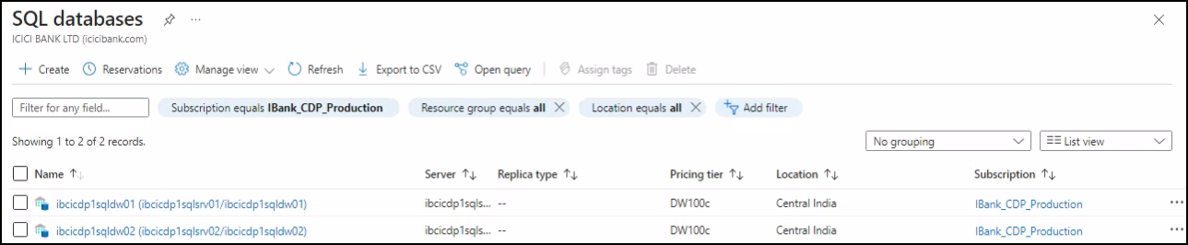

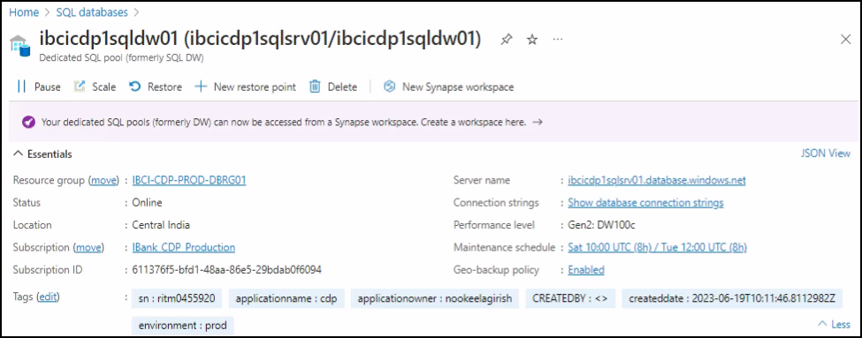

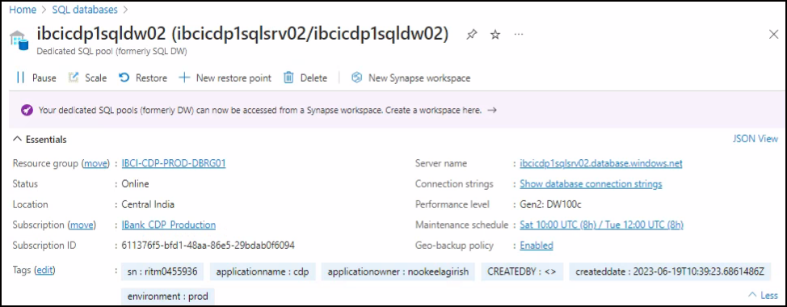

## Cognitive Services

Cognitive Services is a product bundle that enables customers to access multiple services with a single API key.

Product features: Access to Vision, Language, Search, and Speech services using a single API, quickly connect services together to achieve more insights into your content, Easily integrate with other services like Azure Search.

Yet To Deploy

ss

## Synapse Service for Private Eye

Create a Synapse workspace to develop an enterprise analytics solution and choose the authentication method for access to workspace resources such as SQL pools. The authentication method can be changed later.

Yet To Deploy

# Acronyms

|  |  |
| --- | --- |
| **Term** | **Definition** |
| CDP | Cloud Data Platform |
| CI | Central India |
| DNS | Domain Name System |
| IAAS | Infrastructure As a Service |
| RBAC | Role Based Access Control |
| VPN | Virtual Private Network |
| VNET | Virtual Network |
| NSG | Network Security Group |
| UDR | User Defined Route |
| VM | Virtual Machine |
| PAAS | Platform as a Service |
| ADF | Azure Data Factory |
| ADLS | Azure Data Lake Storage |